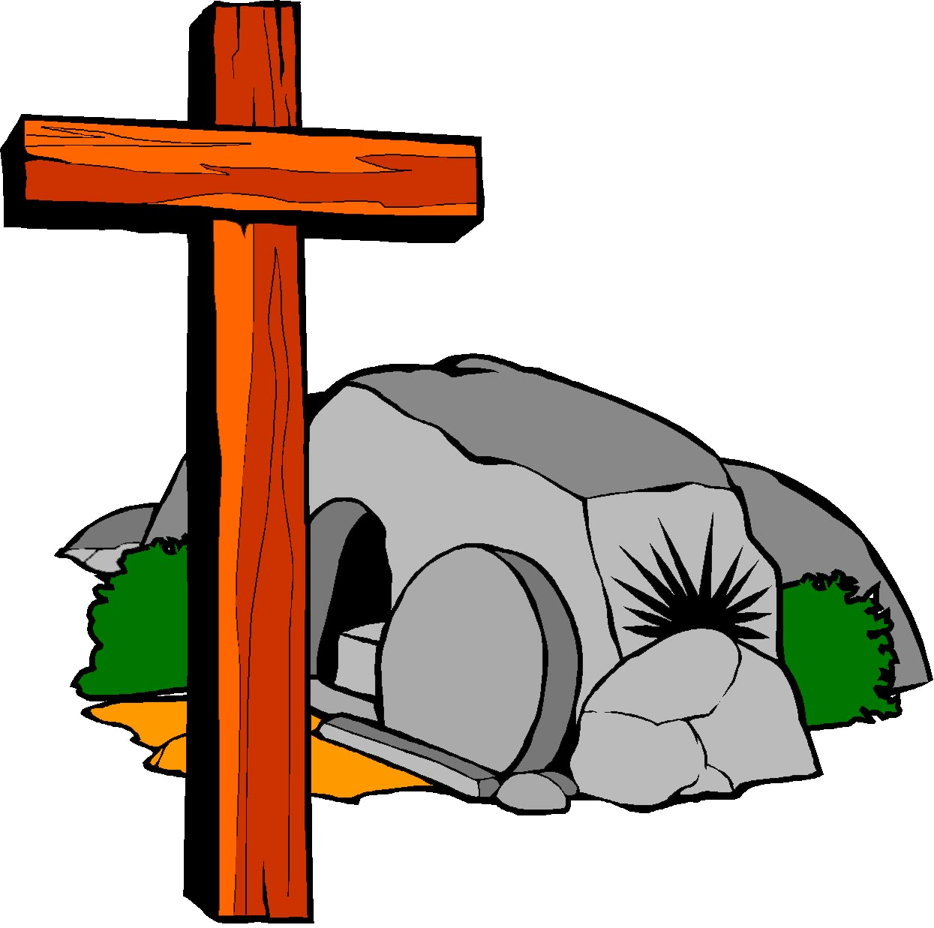
Who I Am in Christ – 1 Developing a Biblical Worldview in Children
I am completely forgiven and made righteous.
Who I Am in Christ – 2 Developing a Biblical Worldview in Children
I have been given the mind of Christ.
Who I Am in Christ – 3 Developing a Biblical Worldview in Children
I am a child of God.
Who I Am in Christ – 4 Developing a Biblical Worldview in Children
I am a son of God.
Who I Am in Christ – 5 Developing a Biblical Worldview in Children
I have direct access to God.
Who I Am in Christ – 6 Developing a Biblical Worldview in Children
I have been given a spirit of power.
Who I Am in Christ – 7 Developing a Biblical Worldview in Children
I am a new creation.
Who I Am in Christ – 8 Developing a Biblical Worldview in Children
I am an heir of God.
Who I Am in Christ – 9 Developing a Biblical Worldview in Children
I belong to God.
Who I Am in Christ – 10 Developing a Biblical Worldview in Children
I am the temple of God.
Who I Am in Christ – 11 Developing a Biblical Worldview in Children
I am God’s handiwork.
Who I Am in Christ – 12 Developing a Biblical Worldview in Children
I am righteous and holy.
Who I Am in Christ – 13 Developing a Biblical Worldview in Children

