CHILDREN’S BIBLE STUDY

**MOTTO: MADE TO MAGNIFY GOD!**

**THEME VERSE: Psalm 34:3**

**PREPARE:**

1. **Know the ROLE**
2. **Know the KIDS – AGE/NEEDS**
3. **Know the CONTENT**
4. **Know the PLAN**
5. **Know it CONTINUES**

**Curriculum is a guide. Read it, pray on it, and adapt to your space, supplies and group of kids.**

**CONTENT:**

**Plan your lessons**

**Each lesson has 5 elements:**

1. **Start It -_ZOOM IN**
2. **Learn It – MAIN BIBLE STORY**
3. **Know it – VERSE REVIEW**
4. **Live It – APPLICATION**
5. **End It – ACTIVITIES**

**(Each day will include a lesson visual example and an example of one of the lesson elements)**

**DAY 1**

**BIG TRUTH:** God created everything there is, and yet He still wants to spend time with me.

**ZOOM IN:** I am important to God.

**TODAY’S POINT:** God sees me

**BIBLE STORY:** Jesus and the Children

**SCRIPTURE:** John 1:1-3, 12; Mark 10:13-16

**BONUS VERSE:** John 1:12

**__________________________________________________________________________________________________________________________________________________________________________________________________________________**

**DAY 2**

**BIG TRUTH:** God keeps the whole universe going, and yet He still cares about what’s happening to me.

**ZOOM IN:** I can trust God to take care of me.

**TODAY’S POINT:** God cares about me.

**BIBLE STORY:** Jesus Calmed the Storm

**SCRIPTURE:** Mark 4:1; 35-41

**BONUS VERSE:** Deuteronomy 31:8b

**__________________________________________________________________________________________________________________________________________________________________________________________________________________**

**DAY 3**

**BIG TRUTH:** God is not OK with sin, and yet He still loves sinners like me.

**ZOOM IN:** I can be confident God loves me.

**TODAY’S POINT:** God loves me.

**BIBLE STORY:** The woman at the well.

**SCRIPTURE:** John 4:1-42

**BONUS VERSE:** Romans 5:8

**______________________________________________________________________________________________________________________________________________________________________________________________________________________________________________________________________________________________________**

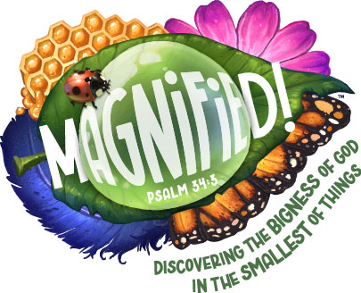

**DAY 4**

**BIG TRUTH:** Jesus came to save the world, and that includes me.

**ZOOM IN:** I can trust Jesus as my Savior.

**TODAY’S POINT:** God forgives me.

**BIBLE STORY:**  Jesus and Nicodemus

**SCRIPTURE:** John 3:1-21; 18-20, 1 Cor 15:6

**BONUS VERSE:** John 3:16

**____________________________________________________________________________________________________________________________________________________________________________________________________________________________________________________________**

**DAY 5**

**BIG TRUTH:** God is faithful with the big things in my life, and He will be faithful with the small things too.

**ZOOM IN:** I don’t have to worry because God keeps His promises.

**TODAY’S POINT:** God keeps His promises

**BIBLE STORY:** Jesus taught about worry.

**SCRIPTURE:** Matthew 6:25-34

**BONUS VERSE:** Psalm 100:5

**__________________________________________________________________________________________________________________________________________________________________________________________________________________**

**PLENTY TO DO:**

**ALWAYS PLAN MORE THAN YOU THINK YOU NEED JUST IN CASE: ANOTHER ACTIVITY DOESN’T WORK, GLITCH IN THE TIME, KIDS NEED A DISTRACTION, ETC.**